Group A [10x1=10]
1.Tick the correct answer.
a.Which is an even number ?
i.252 ii.255 iii.257
b.Which is an odd number?
i.524 ii.578 iii.543
c.There are_________ days in a year.
i.356 ii.365 iii.376
d.A cuboid has ________faces.
i.5 ii.6 iii.7
e.A circle has _________sides.
i.0 ii.1 iii.3
f.A rectangle has_________ corners.
i.3 ii.2 iii.4
g.24÷8=_________
i.3 ii.2 iii.1
h.11×10=________
i.1110 ii.100 iii.110
i.58-39=_________
i.29 ii.19 iii.39
j.48+43=_________
i.81 ii.71 iii.91
Group “B” [12x2=24]
2.Add the following.
3 7 9 5 8 2
4 5 5 3 6 9

3.Subtract the following.
9 8 0 6 0 5
4 2 3 2 5 4

4.Multiply the following.
5 7 5 2
4 3 5 9

5.Divide the following.
4) 2 0 ( 6 ) 3 0 (

6.Write their Roman numerals .
11= 8=
13= 4=
7.What comes after?
456 _______ 688_______
911 _______ 720_______
8.Write “odd” or “even”.
82= _______ 68=_______
987=_______ 504=______
9.Put <,>or= in the boxes.
i.956 221 ii.105 205 iii.765 765 iv.812 820
10.Match the following.
Quadrilateral
Triangle
Circle
Square
11.Fill in the blanks.
a.A triangle has ___________corners.
b.A square has ____________corners.
c.A quadrilateral has________ sides.
d.A rectangle has ___________sides.
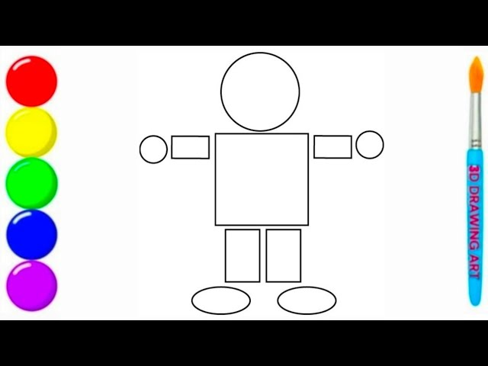
12.Count and write the shapes.
Shapes | How many?
Square
Circle
Rectangle
Triangle

13.Name each of the following lines.
B
C
E
D

is a straight line is a curved line
Group “C”[4x4=16]
14.Solve the following word problems.
a.There are 585 people in a village. 376 of them are males . How many of them are females?
There are _______females.

b.Binaya had 68 balloons. 49 balloons burst. How many balloons were left?
_______Balloons were left.

15.Add the following.
7 | 5 | 5
7 | 4 | 8
1 | 8 | 9
5 | 7 | 8
6 | 9 | 0
5 | 8 | 4

16.Solve the following word problems.
a.In a school, there are 446 boys and 453 girls. How many students are there in the school?
There are_____ students in the school.
b.Sheetal collects 235 stamps and Najir collects 134 stamps. How many stamps are collected altogether?
______Stamps are collected altogether.

17.Draw the following
Cuboid | Cube

